Institute of Engineering & Management, Kolkata
Department of Computer Science and Engineering
E-Commerce Purchase Flow Automation Framework
Selenium WebDriver + Python + pytest (Page Object Model)
Capstone Project Report
Selenium / Web UI Testing Coursework
Submitted by:
Srijani Bishnu
Mentor:
Prof. Sourav Malakar

September 29, 2026

Contents
Contents 2
1. Introduction 3
1.1 Objective 3
1.2 Scope 3
1.3 Tools and Technologies Used 3
2. System Design and Architecture 3
2.1 Layered Architecture 4
2.2 Project Folder Structure 4
3. Implementation Details 5
3.1 Configuration Layer 5
3.2 Base Page - Reliability Engineering 5
3.3 Page Objects - Auth, Products, Cart 5
3.4 Data-Driven Testing (JSON / Excel) 6
3.5 End-to-End Test Scenario 6
3.6 Execution Reporting 6
4. Testing and Results 6
4.1 Test Execution 6
4.2 Unit Test Verification 7
4.3 End-to-End Scenario Checklist 7
4.4 Screenshots 8
4.4.1 Unit Test Console Output 8
4.4.2 Registration / Account Information Page 8
4.4.3 Successful Signin 9
4.4.4 Cart Verification 9
4.4.5 HTML Execution Report 10
5. Conclusion 10
5.1 Summary 10
5.2 Future Enhancements 11
5.3 Repository 11

1. Introduction

1.1 Objective
The objective of this project is to design and implement a complete Web UI Test Automation Framework using Python and Selenium WebDriver. The framework automates a full customer purchase journey on a live e-commerce demo site and demonstrates industry-standard practices, including:
- Page Object Model (POM) design for maintainable, reusable page interactions
- Reliable handling of real-world UI obstacles - ad overlays, popups and native browser alerts
- Data-driven testing from JSON or Excel, with upfront validation of test data
- A self-healing test-user strategy that removes flaky, credential-dependent logins
- Screenshot capture at every step and on failure
- A self-contained HTML execution report with embedded screenshots
- Cross-browser execution (Chrome, Firefox, Edge) and headless / slow-motion modes

1.2 Scope
The framework targets the public demo application hosted at https://automationexercise.com as the system under test, covering the complete purchase lifecycle: user registration, login, product search, adding a product to the cart with a chosen quantity, and cart verification. The test account used for each run is created fresh and deleted again at the end of the run, so the suite has no dependency on any pre-existing account and can be re-run indefinitely without manual data reset.

1.3 Tools and Technologies Used
Tool / Library | Purpose
Python 3.9+ | Core programming language
Selenium 4 | Browser automation (driver managed automatically by Selenium Manager)
pytest | Test runner, fixtures and command-line configuration
openpyxl | Reading and validating Excel test data
Page Object Model | Design pattern separating locators/actions from test logic
Custom HTML report generator | Self-contained execution report with embedded screenshots

2. System Design and Architecture

2.1 Layered Architecture
The framework follows a layered design so that responsibilities are cleanly separated and the codebase stays maintainable and reusable:
- Test Layer - pytest test functions describing the purchase-flow scenario in plain, readable steps.
- Step Runner Layer - times each step, captures a screenshot, and records PASS / FAIL / WARN to the report.
- Page Object Layer - one class per page (HomePage, AuthPage, ProductsPage, CartPage) exposing actions such as login() or add_to_cart().
- Base Page Layer - shared, hardened Selenium primitives: waits, retrying clicks, ad-overlay removal, alert handling, dropdown selection.

Test Layer (tests/test_purchase_flow.py)
|
v
Step Runner (utils/steps.py) --- timing, screenshots, PASS/FAIL/WARN
|
v
Page Object Layer (HomePage / AuthPage / ProductsPage / CartPage)
|
v
Base Page (waits, retrying clicks, ad removal, alerts, dropdowns)
|
v
Selenium WebDriver --> Browser --> automationexercise.com

2.2 Project Folder Structure
ecommerce_v2/
├── conftest.py # fixtures + report hooks
├── pytest.ini
├── requirements.txt
├── config/
│ └── settings.py # URL, browser, headless, timeouts
├── data/
│ ├── test_data.json
│ └── test_data.xlsx
├── pages/
│ ├── base_page.py # waits, retrying clicks, ad removal
│ ├── home_page.py
│ ├── auth_page.py # login and signup
│ ├── products_page.py
│ └── cart_page.py
├── utils/
│ ├── driver_factory.py # Chrome / Firefox / Edge setup
│ ├── data_reader.py # JSON and Excel + validation
│ ├── user_factory.py # unique test-user generation
│ ├── steps.py # timing, screenshots, logging
│ ├── report.py # HTML report generator
│ └── helpers.py
└── tests/
├── test_purchase_flow.py # the end-to-end scenario
└── unit/
└── test_utils.py # fast offline unit tests

3. Implementation Details

3.1 Configuration Layer
All environment-specific values (target URL, browser, headless mode, timeouts, slow-motion delay) are centralised in config/settings.py and can be overridden with environment variables, so the same code runs differently in different environments purely through configuration - no code changes required.
BASE_URL = os.getenv("BASE_URL", "https://automationexercise.com")
BROWSER = os.getenv("BROWSER", "chrome").lower() # chrome|firefox|edge
HEADLESS = os.getenv("HEADLESS", "false") == "true"
DATA_FILE = os.getenv("DATA_FILE", "test_data.json") # or test_data.xlsx

EXPLICIT_WAIT = int(os.getenv("EXPLICIT_WAIT", "20"))
SLOW_MO = float(os.getenv("SLOW_MO", "0")) # pause before each action
STEP_PAUSE = float(os.getenv("STEP_PAUSE", "0")) # pause after each step

3.2 Base Page - Reliability Engineering
The demo application under test displays full-page Google ad overlays that intercept clicks on the Login and Signup buttons - the single biggest source of flakiness in a naive Selenium script against this site. BasePage addresses this directly: ad hosts are blocked at network level for Chrome and Edge, ad containers are stripped from the DOM before every interaction, and a click that is still intercepted is retried and, as a last resort, issued via JavaScript.
def click(self, locator, timeout=None):
for _ in range(3):
try:
element = self._wait(timeout).until(
EC.element_to_be_clickable(locator))
self._slow(element)
element.click()
return
except (ElementClickInterceptedException,
ElementNotInteractableException,
StaleElementReferenceException):
self.remove_ads()
self.scroll_to(locator)
except UnexpectedAlertPresentException:
self.accept_alert()
# last resort if the overlay never clears
self.driver.execute_script(
"arguments[0].click();", self.presence(locator))

3.3 Page Objects - Auth, Products, Cart
Each page exposes intent-revealing methods rather than raw Selenium calls. AuthPage.login() waits for either a logged-in state or the site's own error message and raises a descriptive AuthError instead of leaving the test to time out with no explanation:
def login(self, email, password):
self.type_text(self.LOGIN_EMAIL, email)
self.type_text(self.LOGIN_PASSWORD, password)
self.click(self.LOGIN_BUTTON)

status, message = WebDriverWait(self.driver, 15).until(outcome,
'Neither a logged-in state nor a login error appeared')
if status == 'error':
raise AuthError(f"Login rejected for '{email}': {message}")

3.4 Data-Driven Testing (JSON / Excel)
Test data can be supplied as either JSON or Excel - both are parsed into an identical dictionary structure and validated before any browser is launched, so a misconfigured run fails fast with a readable list of problems rather than an obscure Selenium error midway through the test:
def validate_test_data(data):
problems = []
if data.get('user_mode') not in ('new', 'existing'):
problems.append("user_mode must be 'new' or 'existing'")
if not str(data.get('search', {}).get('product_keyword', '')).strip():
problems.append('search.product_keyword is empty')
if problems:
raise ValueError('Invalid test data:\n - ' + '\n - '.join(problems))

3.5 End-to-End Test Scenario
The scenario is written as a single pytest function, with each logical step wrapped in a StepRunner context manager that times the step, takes a screenshot, and logs the outcome to the execution report - whether the step passes, fails, or (for the best-effort cleanup step) only warns:
with steps.step('Search product') as s:
home.go_to_products()
products.search(keyword)
found = products.result_count()
assert found > 0, f"No products found for '{keyword}'"
s.details = f"Search '{keyword}' returned {found} product(s)"

3.6 Execution Reporting
utils/report.py builds a single, self-contained HTML file after every run: an overall PASS/FAIL banner, one row per step with its status, duration and details, and every screenshot embedded directly in the file as base64 data - so the report can be emailed or archived as a single artifact with no separate screenshots folder required.

4. Testing and Results

4.1 Test Execution
The full suite (unit tests and the end-to-end browser scenario) is executed with:
pip install -r requirements.txt
pytest
The end-to-end browser scenario can also be run on its own, and adjusted through environment variables:
pytest tests/test_purchase_flow.py
HEADLESS=true pytest tests/test_purchase_flow.py
BROWSER=firefox pytest tests/test_purchase_flow.py
SLOW_MO=1 STEP_PAUSE=2 pytest tests/test_purchase_flow.py

4.2 Unit Test Verification
Before relying on the browser scenario, the offline logic - data loading, validation, unique-user generation, and the report generator - was verified with a dedicated unit test suite that needs no browser and runs in well under a second:
Test | Area covered | Result
test_parse_money | Utility | Passed
test_safe_filename_and_short_error | Utility | Passed
test_new_user_email_is_unique_and_profile_untouched | User factory | Passed
test_json_and_excel_data_are_identical | Data reader | Passed
test_bundled_data_is_valid | Data reader | Passed
test_validation_reports_every_problem | Validation | Passed
test_validation_rejects_unknown_mode | Validation | Passed
test_excel_types_are_coerced | Data reader | Passed
test_report_is_self_contained_html | Report generator | Passed
Result: 9 passed, 0 failed.

4.3 End-to-End Scenario Checklist
The following steps make up the browser-based purchase flow. Run the suite locally against the live application (Section 4.1) and record the actual result and duration of each step from your own execution report:
Step | Type | Expected outcome
Launch browser and open application | Positive (setup) | Home page loads, popups dismissed
Register a new user | Positive | 'ACCOUNT CREATED!' is displayed
Logout | Positive | Redirected to the login page
Login with the new credentials | Positive | 'Logged in as <name>' is displayed
Search for a product | Positive | At least one search result is returned
Update quantity and add to cart | Positive | 'Added!' popup is displayed
Verify cart details | Positive (assertion-heavy) | Name, unit price, quantity and total all match
Cleanup - delete test account | Best effort | Account removed; never fails the test on its own

4.4 Screenshots
The screenshot below is genuine output captured while verifying this framework's offline logic. The remaining figures are placeholders for you to replace with your own screenshots after running the end-to-end suite locally - the report and screenshots folder are generated fresh by every run (see Section 3.6).

4.4.1 Unit Test Console Output
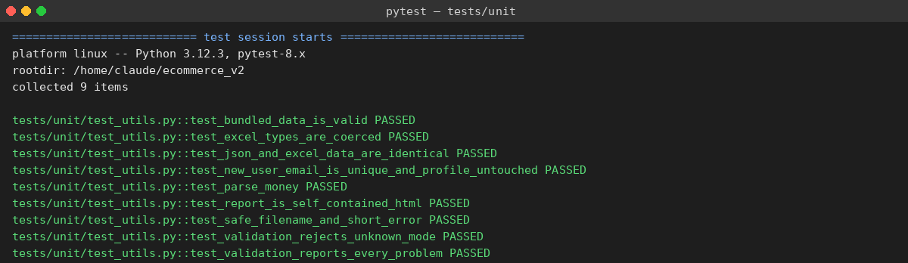
Figure 4.1: Offline unit test suite - 9 passed, 0 failed (genuine output)

4.4.2 Registration / Account Information Page
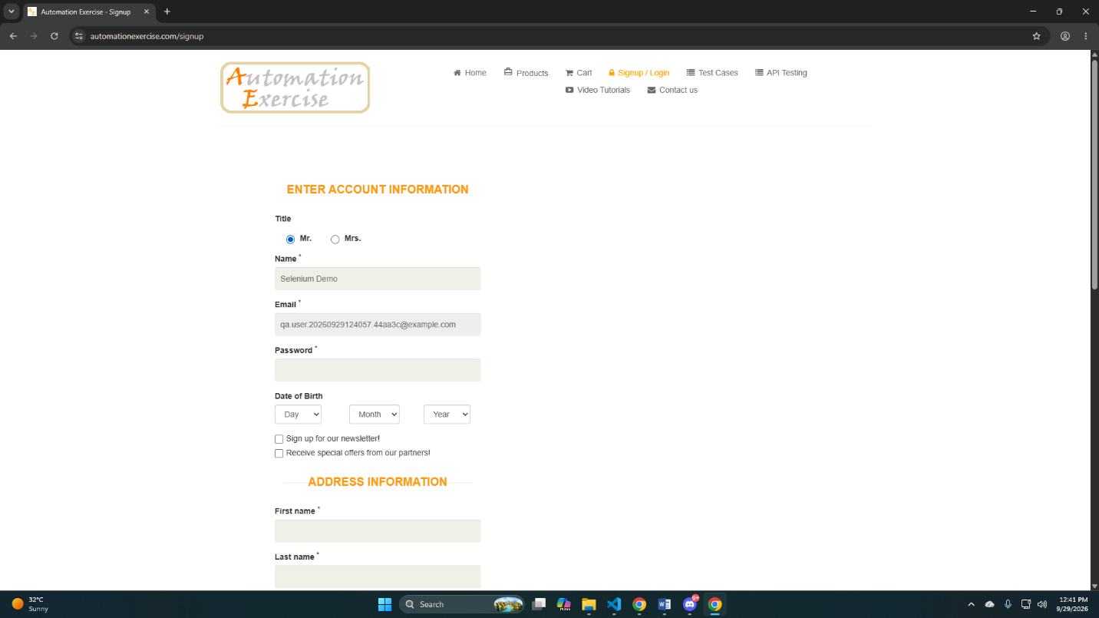
Figure 4.2

4.4.3 Successful Signin
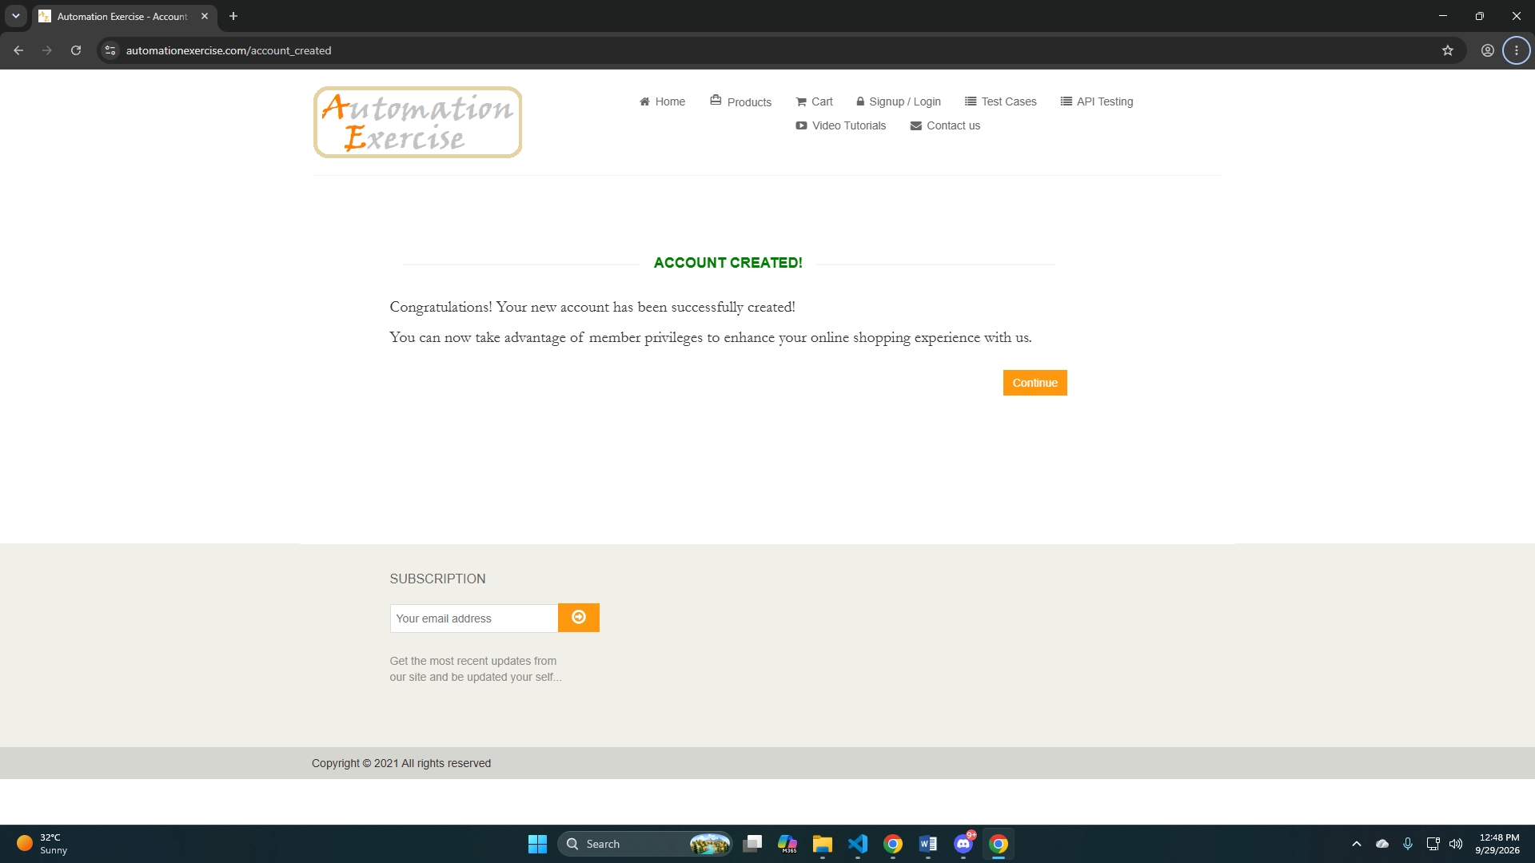
Figure 4.3: Screenshot of successful sign in

4.4.4 Cart Verification
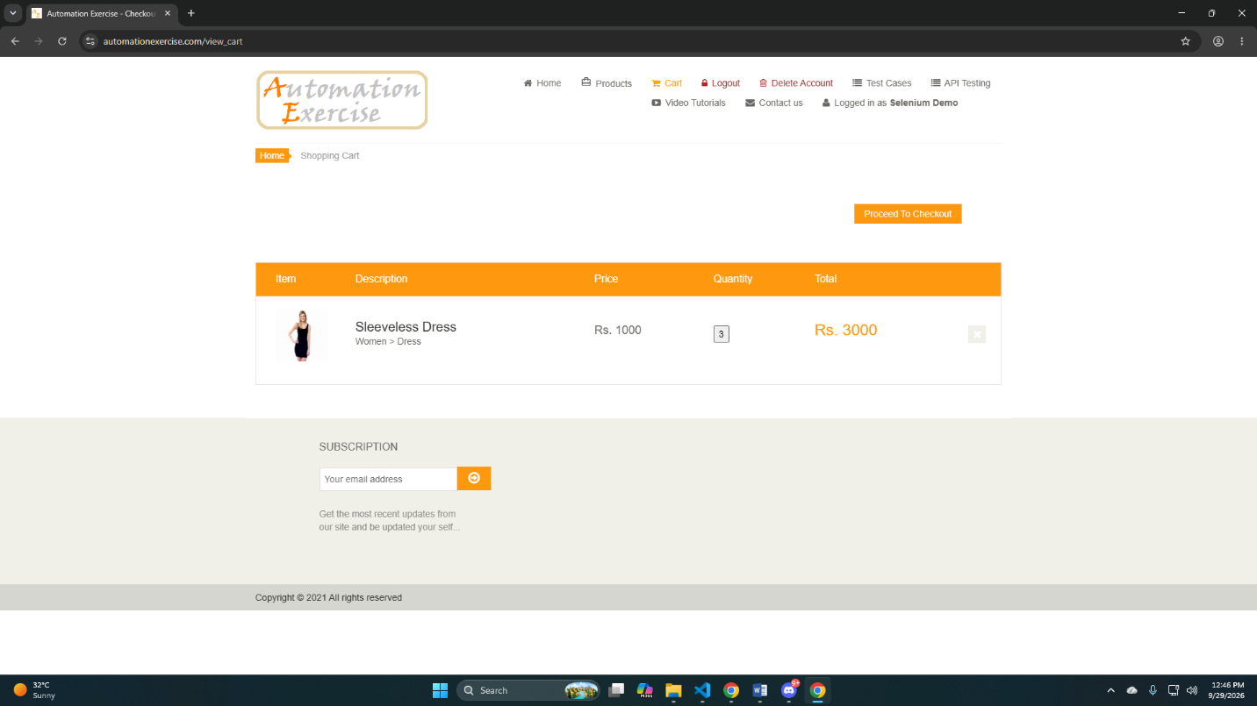
Figure 4.4: Screenshot of the cart page

4.4.5 HTML Execution Report
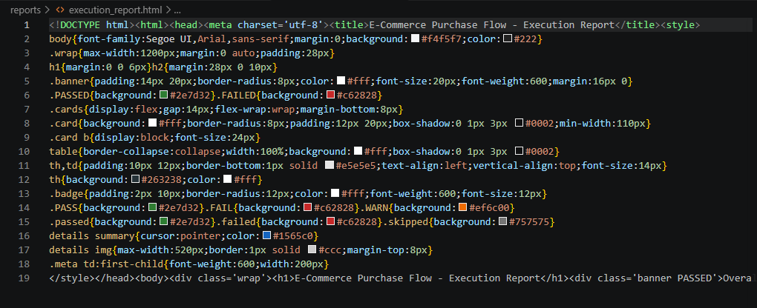
Figure 4.5: Screenshot of reports/execution_report.html

5. Conclusion

5.1 Summary
This project implements a reliable, maintainable Selenium WebDriver automation framework for a complete e-commerce purchase flow, built on the Page Object Model. It specifically addresses the two failure modes that most commonly break UI automation against real-world sites - ad overlays intercepting clicks, and stale or duplicated test credentials - by removing ad overlays before every interaction and generating a fresh, unique test user on every run. The framework is data-driven from JSON or Excel, validates its own inputs before launching a browser, and produces a single self-contained HTML report with every step timed, screenshotted and logged.

5.2 Future Enhancements
- Integrate with a CI/CD pipeline (GitHub Actions) for automated runs on every push
- Add parallel execution (pytest-xdist) to reduce overall run time across browsers
- Extend coverage to checkout, payment, and order-history flows
- Add visual regression checks on key pages using screenshot comparison
- Publish results to a richer reporting tool (e.g. Allure) alongside the existing HTML report

5.3 Repository
The complete source code for this project is available at:
https://github.com/srijan-i/ecommerce-selenium-automation

